_______________________________
Change Effective Date
CHANGE DIRECT DEPOSIT

_____________________________________________________________________________________
Employer’s/Depositor’s Name
_____________________________________________________________________________________
Address
_____________________________________________________________________________________
City State Zip
To whom it may concern:
You are currently depositing my PAYCHECK SOCIAL SECURITY OTHER (check one)
to the following account:
Green Belt Bank & Trust
_____________________________________________________________________________________
Financial Institution Name
073921679
__________________________________________ _______________________________________
Routing Number Account Number
If you have questions about this request, please contact me at:
__________________________________________ _______________________________________
Phone Number Best time to call
Thank you.
Sincerely,
__________________________________________ _______________________________________
Signature Name (print)
__________________________________________ _______________________________________
Address City, State, Zip
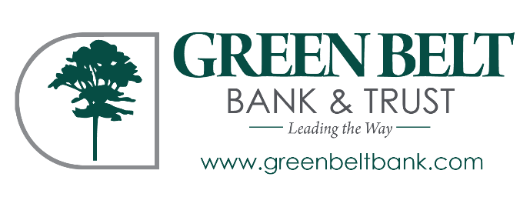
__________________________________________ _______________________________________
Social Security Number Other information needed (Employee ID #, etc.)
(Make as many copies as needed.)

